

ITT569

Internet of Things (IOT)

LAB 3

Mohamad Ajwad Bin Mohd Sobri

2020980417

RCS2515A

Create a Simple Game with Python IDLE

1. Use the idle3 command to launch IDLE. By default, it starts in Python Shell, or interactive interpreter,window. You are already familiar with the interactive interpreter.

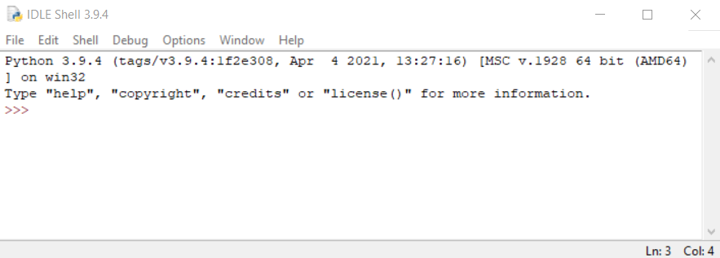

1. Click **File** -> **New File** to open a new (Untitled) Python script.

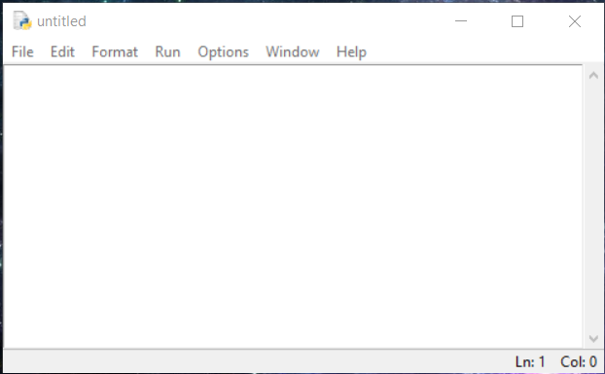

1. Type the codes in the script, and note that the codes are color coded with open and close parentheses  matched

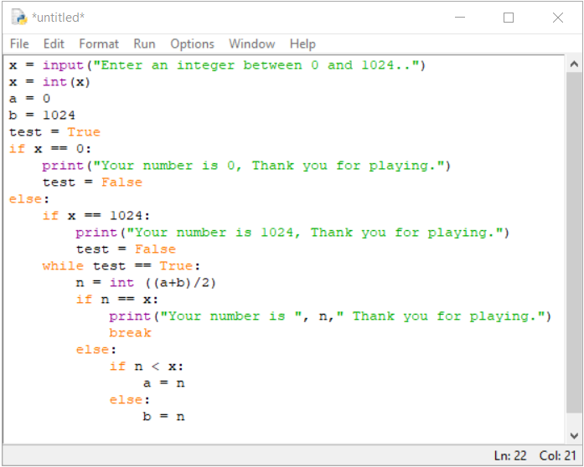

1. Click **File** -> **Save**, and save the current script as 2.py in the current directory. Click the **Save** button.

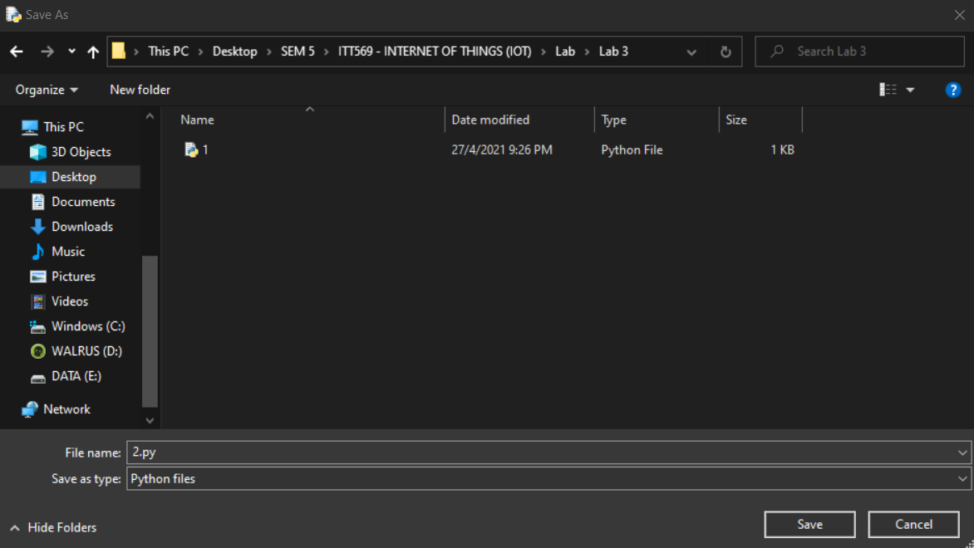

1. Click **Run** -> **Run Module** (or press F5). The shell window will display the result.

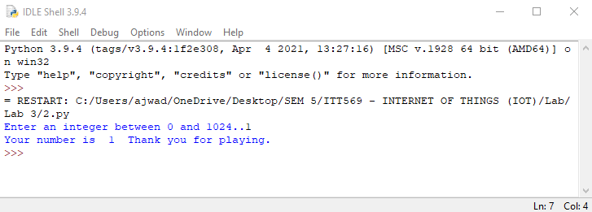

1. Troubleshoot if an error occurs during code syntax evaluation.

Reflection

How to catch if the player enters a number beyond the range of 0 to 1024?

If the number enter is lower than zero and higher than 1024, we can print that the number is

out of range

How to catch if the player enters a float number?

If the number enter is float number, we can take it as a integer by ignoring the decimal